**Lab 011: Review of Waves, Interference and Diffraction**

**Part 1: Review of Waves from Phys 2A**

**Learning Goals:**

Students will be able to:

1. Discuss wave properties using proper scientific vocabulary. (amplitude, wavelength, frequency, period, wave speed) This should all be review from your Physics 2A course.

**Background Information**:

Basics of waves and proper vocabulary <https://youtu.be/_Y28V2NamJg>

**Simulation:**

Open [**Waves on a String**](https://phet.colorado.edu/sims/html/wave-on-a-string/latest/wave-on-a-string_en.html), (simulation from PhET Interactive Simulations at University of Colorado Boulder, under the CC-BY 4.0 license).

Investigate wave behavior. As you explore, think about how you would describe waves and some reasons the waves might act the way they do.

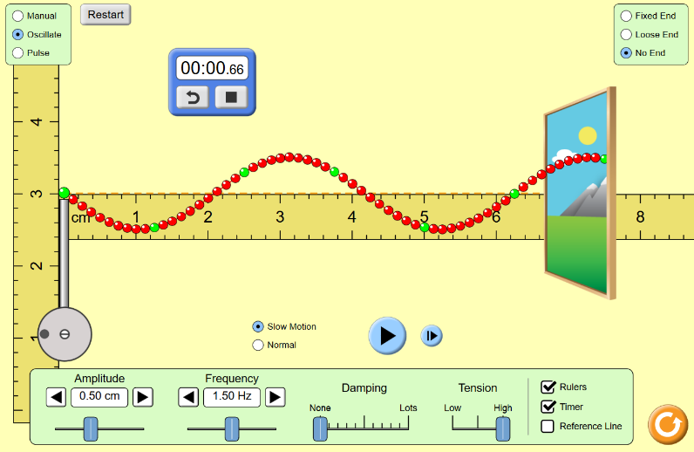

**Investigate and Explain your understanding:**

1. Dscribe each characteristic below in proper scientific vocabulary. Use images to help with the descriptions as needed.
   1. Wave Amplitude – This is the maximum amount of displacement of the wave. Peak Height
   2. Wave Frequency – The number of waves that pass a location within a certain time.
   3. Wave Speed (what does it depend on? Hint: it is NOT the frequency or the wavelength! Check the review videos.) – This is how far the wave travels in each amount of time. The farther it travels in a shorter time period, the faster the speed of the wave.
   4. Wave Period – This is the distance between the peeks or valleys.

**For steps 2-5:** Investigate waves with *Oscillate* and *No End*, and set “*Damping*” to “*none*.”

**Tips:** Helpful tools  and 

1. Using the ruler and stopwatch tools, devise a way to measure the wave speed. (hint: see the first image in these instructions)
   1. Describe your method of determining the speed of the wave.

Speed = Wavelength X frequency

0.06375 = 0.0425cm X 1.5 hz

* 1. Does changing the amplitude change the speed of the wave? Make measurements and give evidence.

Yes, it increases or decreases the size of the wave or the wavelength. If you change the amplitude from .75cm to 1.25cm you increase the distance of the wave and push it out to .0625 cm from the previous .0425.

* 1. Does changing the frequency change the speed of the wave? Make measurements and give evidence.

Yes, because it also changes the distance of the waves by speeding up or slowing down the wave. When you increase the frequency from 1.5 hz to 3.0 hz you change the wavelength from 0.0425 cm to 0.02 cm.

* 1. Does changing the tension change the speed of the wave? Make measurements and give evidence.

Yes, this changes the wavelength. If you decrease the tension from high to medium you will decrease the wavelength from 0.0425 cm to 0.025 cm

**Test your understanding:**

The figure below shows a rope on a smooth floor with a knot at point A. Someone has shaken the end sideways to make a pulse that is moving to the **right** in the image. You are looking down and taking a movie of the motion. Below is one freeze frame of the movie.

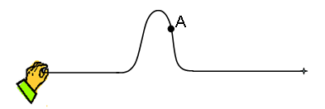

**Use the “highlight” tool to choose your answer for each situation in 1-8 of this section:**

1. If you advance the movie one frame, the knot at point A would be:

a) in the same place b) higher c) lower d) to the right e) to the left

1. If the person generates a new pulse like the first but more quickly, the pulse would be:

a) same size b) wider c) narrower

1. If the person generates another pulse like the first but he moves his hand further, the pulse would be:

a) same size b) taller c) shorter

1. If the person generates another pulse like the first but the rope is tightened, the pulse will move:

a) at the same rate b) faster c) slower

Now the person moves his hand back and forth several times to produce several waves. You freeze the movie and get this snapshot.

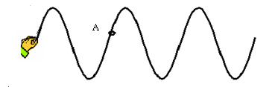

1. If you advance the movie one frame, the knot at point A would be:

a) in the same place b) higher c) lower d) to the right e) to the left

1. If you advance the movie one frame, the pattern of the waves will be _________ relative to the hand.

a) in the same place

b) shifted right

c) shifted left

d) shifted up

e) shifted down

1. If the person starts over and moves his hand more quickly, the peaks of the waves will be:

a) the same distance apart b) further apart c) closer together

1. If you lower the frequency of a wave on a string you will:   
   a) lower its speed. b) increase its wavelength. c). lower its amplitude. d) shorten its period.

9. Consider this wave approaching a fixed end (the clamp):

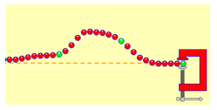

Which shows the wave after it reflects? **_B__**

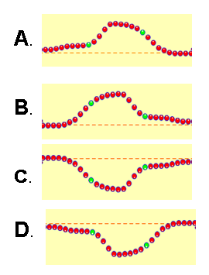

**Part 2: Wave interference**

**Learning Goals:**

Students will be able to:

1. Make waves with water, sound, and light and see how they are related.
2. Discuss wave properties using proper scientific vocabulary.
3. Explain how changing the frequency and amplitude affects the characteristics of the wave.
4. Design an experiment to measure the speed of the wave, regardless of the medium.

**Simulation:**

This section uses the [**Waves Interference**](https://phet.colorado.edu/sims/html/wave-interference/latest/wave-interference_en.html) simulation from PhET Interactive Simulations at University of Colorado Boulder, under the CC-BY 4.0 license.

**Develop your understanding:**

Open the [**Waves**](https://phet.colorado.edu/sims/html/wave-interference/latest/wave-interference_en.html?screens=1) screen, then explore to make water waves and devise ways to observe and measure the waves.

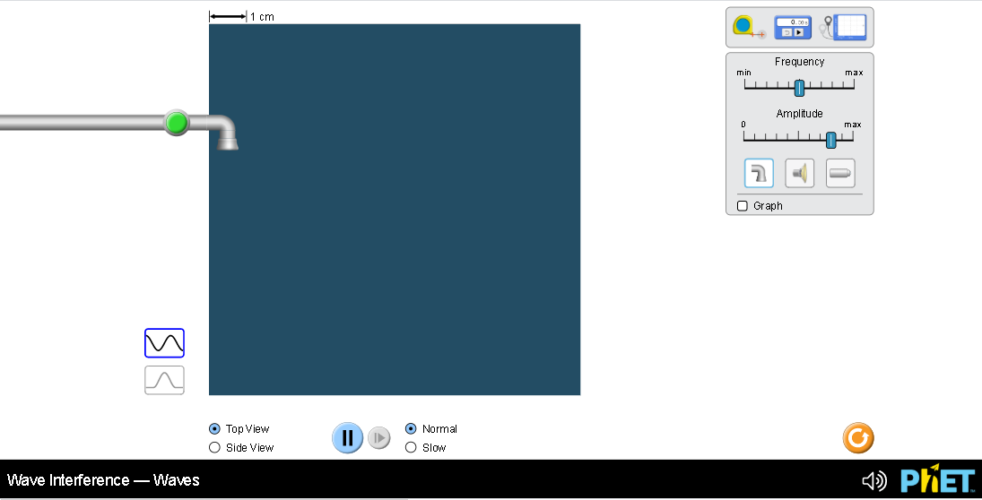

**Explain your understanding of water waves:**

1. Use your own words and captured images from the simulation to show you can measure:
   1. Wavelength of longest wave possible

I was able to get around 7.8cm by changing the frequency to min and amplitude to max.

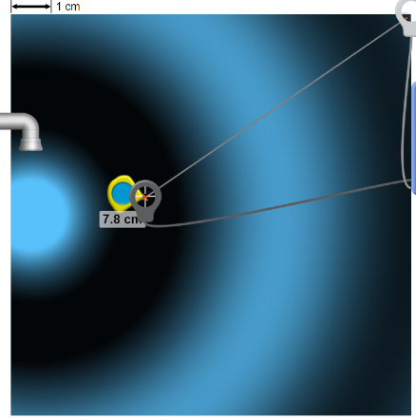

* 1. Wavelength of shortest wave possible

I was able to get a 1.6cm wave by increasing the frequency and amplitude both to max.

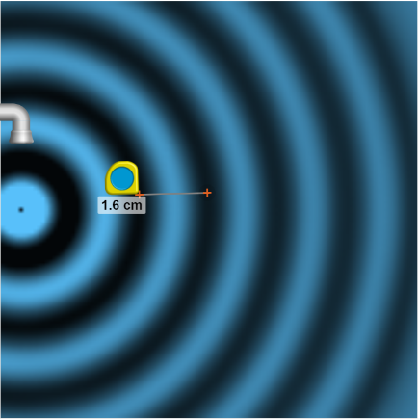

* 1. Height of tallest wave possible

The tallest wave was about .6cm from max settings.

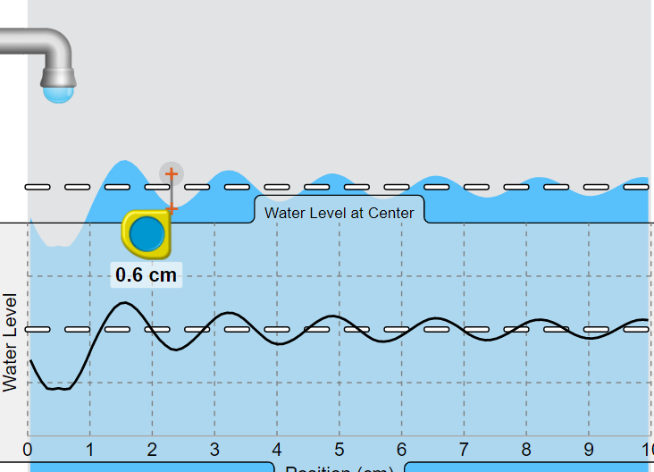

1. Describe your experiments to make waves of different wavelengths and heights including which views and tools were needed and why. Support your explanation with images from the simulation.

I needed to adjust the Frequency and Amplitude to change the width and height of the wave. I also used the top down view to see the wavelength and the top down view to view the height and speed.

1. Use your own words and captured images from the simulation to show you can or cannot measure:  
   1. Speed of longest wave possible

Speed = Wavelength X frequency

0.1659 = .053 m X 3.13 hz

* 1. Speed of shortest wave possible

Speed = Wavelength X frequency

0.0163 = .016 m X 1.02 hz

* 1. Speed of tallest wave possible

Speed = Wavelength X frequency

0.0163 = .016 m X 1.02 hz

1. Describe your experiments to measure speed including which views and tools were needed and why. Support your explanation with images from the simulation.

I needed to adjust the Frequency and Amplitude to change the width and height of the wave. I also used the top down view to see the wavelength and the top down view to view the height and speed.

**Develop your understanding of sound and light waves:**

Use the  buttons to make sound and light waves of varying wavelengths.

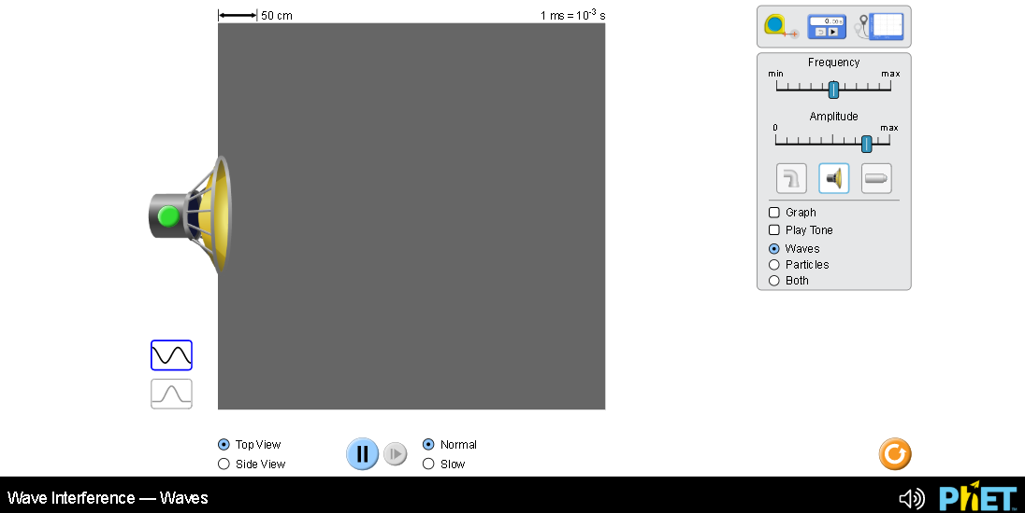

1. Compare the representations of water, sound, and light waves. Describe the similarities and differences with images from the simulation to support your ideas.

They are all very similar between the mediums. It looks like the wavelengths are the same or very close. How the different mediums create waves are the main difference.

1. Experiment to measure the wavelength, height, period, and speed of sound waves. How do your ideas from measuring water waves compare? Describe the similarities and differences with images from the simulation to support your ideas.

Wavelength = 108.8 cm

Height = 0.5 cm

Period = 3 ms

Speed = 0.324

They can be measured the same way.

1. Experiment to measure the wavelength, height, period, and speed of light waves. How do your ideas from measuring water and sound waves compare? Describe the similarities and differences with images from the simulation to support your ideas.

Wavelength = 0.0000536cm (5.36e-5)

Height = 0.0000000005 m (5e-10)

Period = 0.000000000002 ms (2e-12)

Speed = 1.072e-16

They can be measured the same way.

1. Summarize key ideas that you want to remember about the relationships between water, sound and light waves.

They can all be measured the same way, they all look very similar.

**Develop your understanding:**

Open the [**Interference**](https://phet.colorado.edu/sims/html/wave-interference/latest/wave-interference_en.html?screens=2) screen, then explore to make water waves with varying patterns.

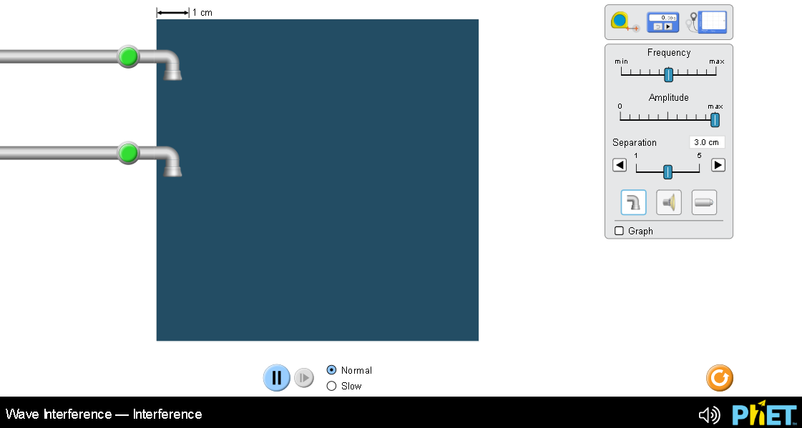

**Explain your understanding:**

1. Consider thesethree patterns of water waves:

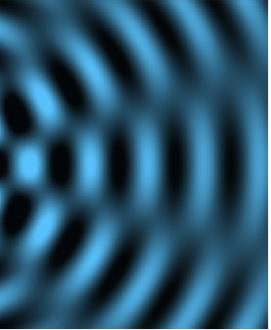

A B C

1. Describe the similarities and differences of thethree patterns of water waves.

They all have peaks and valleys, the wavelengths are all pretty close to the same distance.

1. Experiment to make similar patterns, then explain how you can use the simulation to make each.
2. Have both faucets on at the same time and same rate. Using base settings gets the closest.
3. Both Faucets on and increase the frequency to the max.
4. Have only one faucet on set to max frequency.
5. Why do the directions say “similar patterns”?

To try and match what is shown in the images to match what is on my simulator.

1. Experiment to make waves of different interference patterns with water, sound, and light. Use your own words and captured images from the simulation to show you can meet learning goal A: “Create an interference pattern with two sources, and determine the ways to change the pattern.”

The water, sound and light all react very similar. They all produce waves and when two waves conflict they create a checkerboard pattern.

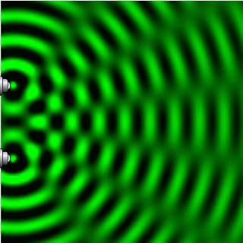

When you increase the distance between the two devices that produce a tighter checker board effect.

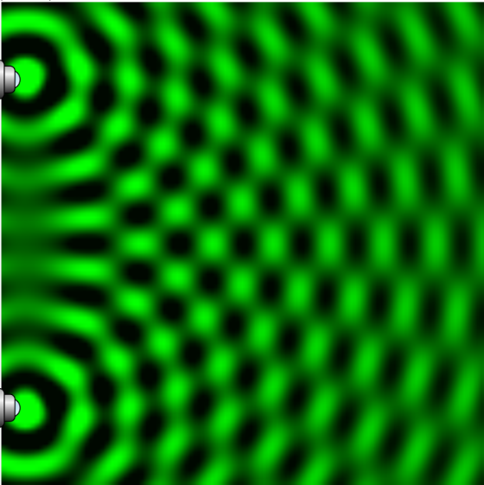

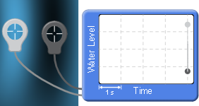

1. Use the Water Level tool to understand what is happening in the water tank:
   1. Measure the dark and light areas of waves made with only one faucet. Insert a screen image to help explain your answer.

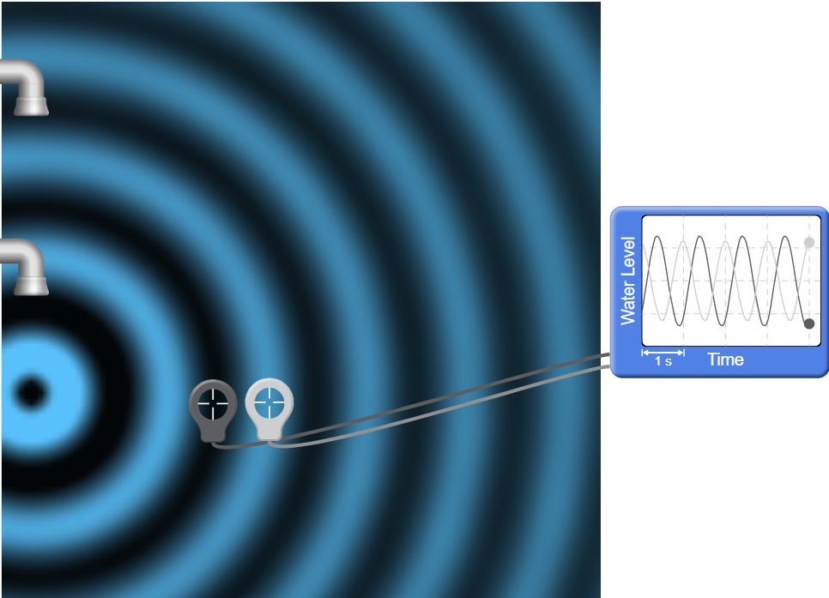

* 1. Make waves using both faucets and measure the dark, light and fuzzy spots. Insert a screen image to help explain your answer.

– answer here

* 1. What do you think constructive and destructive interference means based on your measurements?

– answer here

* 1. Verify your understanding using your text or online references. (cite references

– answer here

**Part 3: Diffraction of waves**

**Background information:**

1. Basic Diffraction:

<https://youtu.be/1bHipDSHVG4>

2. Interference patterns:

<https://youtu.be/CRhsPoTOHIU>

2. Double slit diffraction:

<https://youtu.be/nuaHY5lj2AA>

4. More:

part 1: <https://youtu.be/Pk6s2OlKzKQ>

part 2: <https://youtu.be/1abpdO27KTo>

**Develop your understanding:**

Open the [**Diffraction**](https://phet.colorado.edu/sims/html/wave-interference/latest/wave-interference_en.html?screens=4) screen, then explore to see what happens to light waves when they pass through different shaped holes.

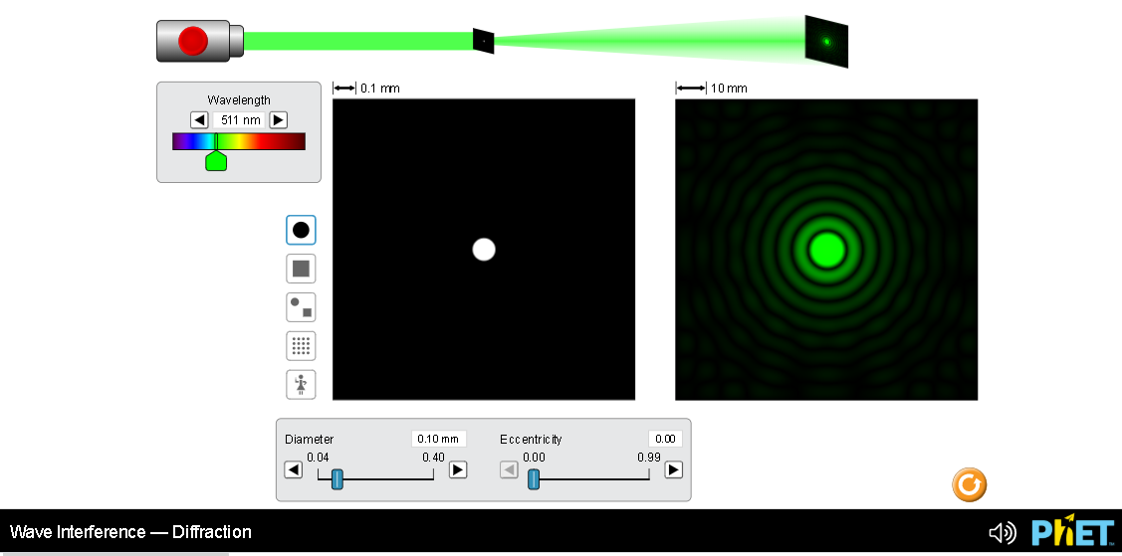

**Explain your understanding:**

1. Open the full simulation [**Waves Interference**](https://phet.colorado.edu/sims/html/wave-interference/latest/wave-interference_en.html) so that you can experiment with both the **Slits** and **Diffraction** screens.
   1. Explain why light passing through a round hole makes that pattern. Explain what you think is happening including images for support.

The light beam prior to passing through the hole is traveling at a certain speed and width. Once the light reaches the smaller round hole, the light is slowed down and restricted to passing through a small hole. This will slow the outer ring of light down and force it to radiate outward at a slower rate.

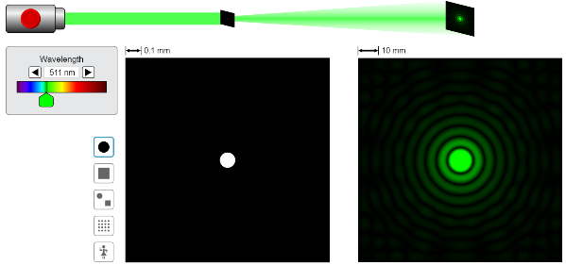

* 1. Switch to a double slit configuration, and compare patterns of varying slit size to patterns of varying size. Include images for support.

The light beam prior to passing through the slits are moving at a certain speed, once they pass through the speed, they are force to slow down and radiate. Because there are two traveling at the same rate of speed they conflict and bounce off each other shortly after passing through the slits. This creates a water ripple effect in the light.